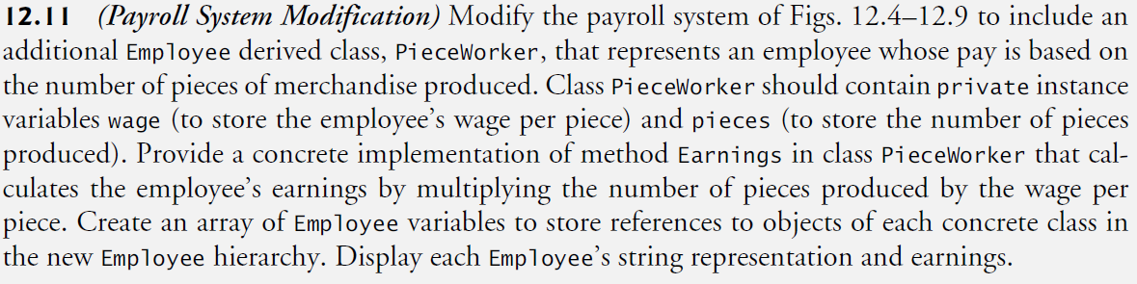

* (Payroll System Modification) Modify the payroll system of Figs. 12.4–12.9 to include an additional Employee derived class, PieceWorker, that represents an employee whose pay is based on the number of pieces of merchandise produced.
* Class PieceWorker should contain private instance variables wage (to store the employee’s wage per piece) and pieces (to store the number of pieces produced).
* Provide a concrete implementation of method Earnings in class PieceWorker that calculates the employee’s earnings by multiplying the number of pieces produced by the wage per piece.
* Create an array of Employee variables to store references to objects of each concrete class in the new Employee hierarchy. Display each Employee’s string representation and earnings.